# 1.Introduction

### 1.1 Project Name

University career website.

### 1.2 Developer

Member 1: Li Cheng

Member 2: YuHan xue

### 1.3 Project development environment

#### 1.3.1 Hardware

Macbook Pro(Retina,Mid 2013)（Windows computer is ok ）

#### 1.3.2 Software

Intellij IDEA + macos high Sierra or Intellij IDEA +Windows 10

#### 1.3.3 DataBase

Mysql 5

#### 1.3.4 Development Technology

Springboot+javascript+html+css+Maven

# 2. Code explanation of each module in the System.

### 2.1 login module

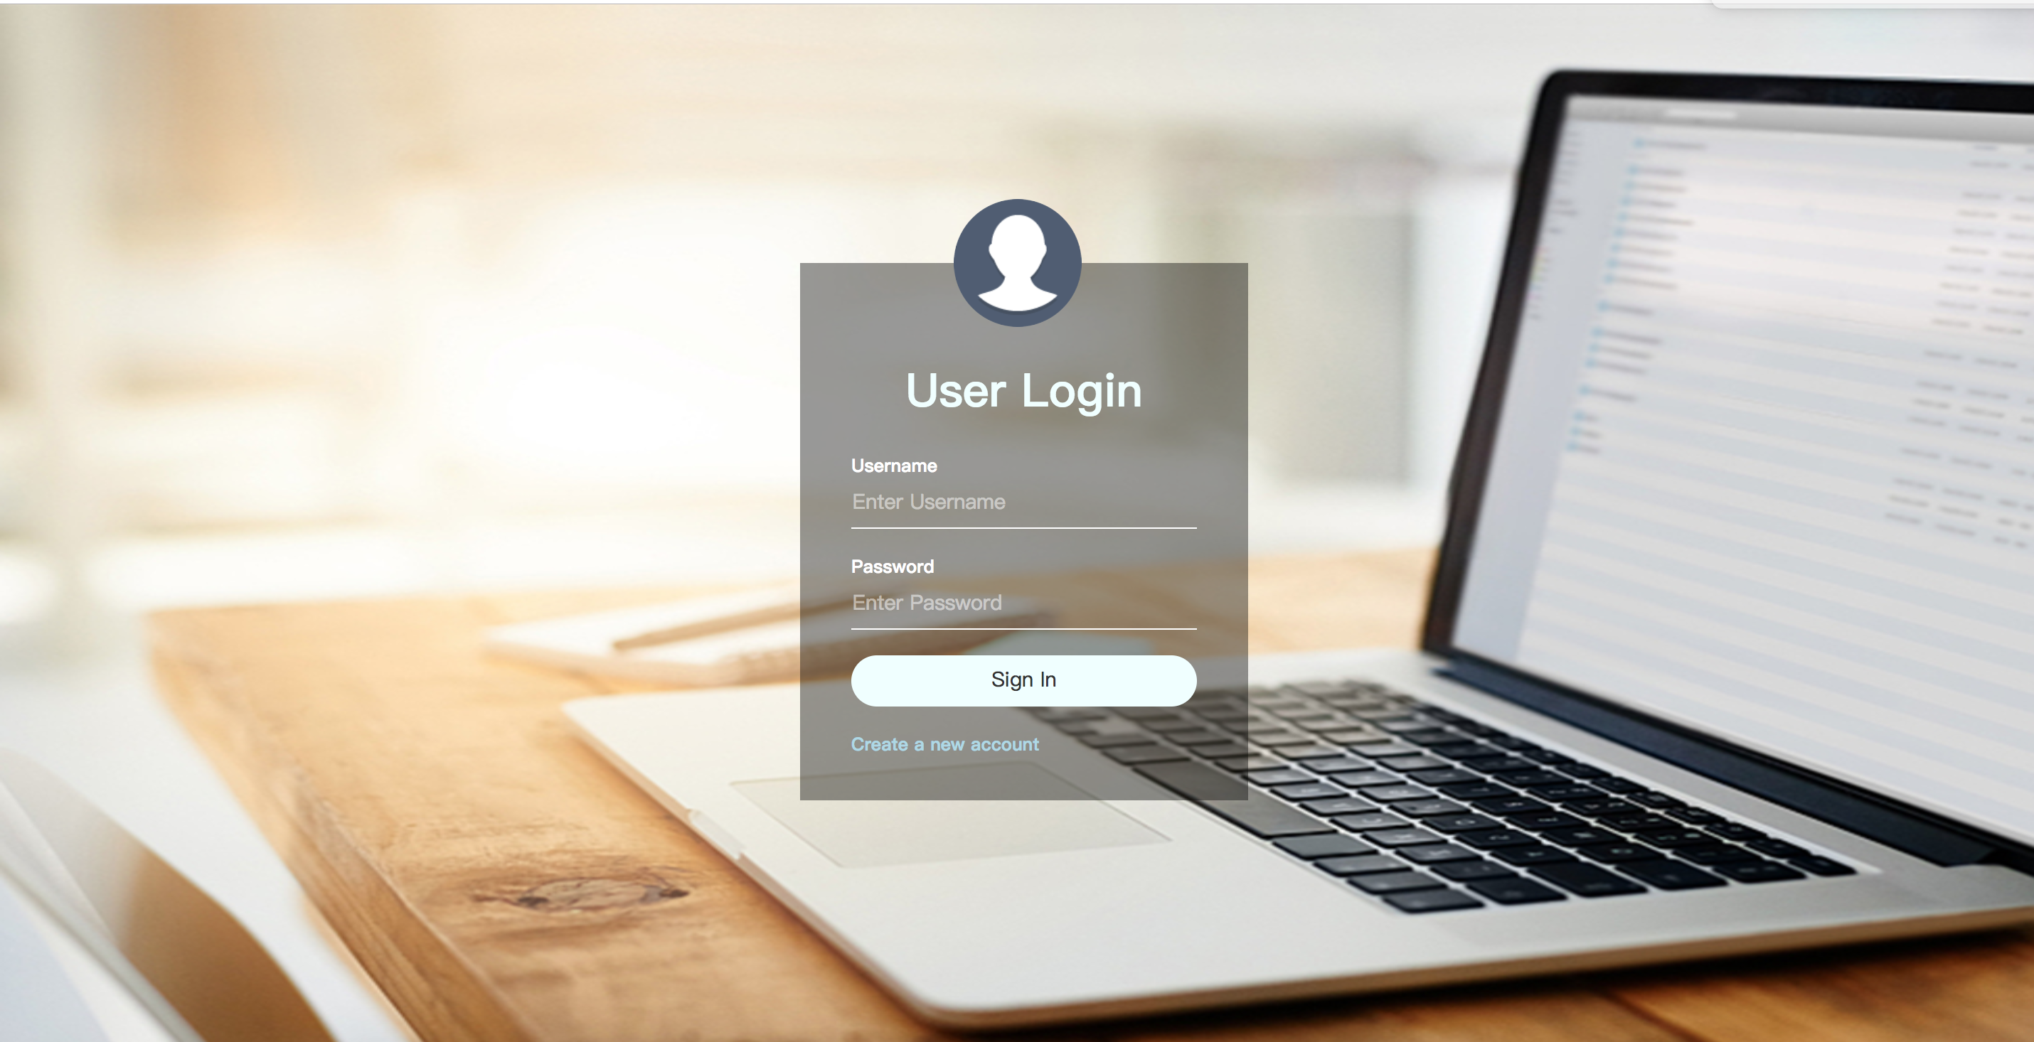

Key code in the login module.

2.1.1View part (WEB-INF/jsp/login.jsp) :

<**script type="text/javascript"**>  
 **function** *check*(){  
 **var** list = ***document***.getElementsByTagName(**"input"**);  
 **for**(**var** i=0;i<list.length;i++){  
 **if**(list[i].**value**==**""**){  
 *alert*(**"you should fill out the form"**);  
 **return false**;  
 }  
 }  
 **return true**;  
 }  
</**script**>

<**form method="post" action="${**pageContext.request.contextPath**}/login.do" onsubmit="return** *check*()**"**>  
 <**div**>  
 <**p**>Username</**p**>  
 <**input type="text" id="Username" placeholder="Enter Username" name="username"**/>  
 </**div**>  
  
 <**div**>  
 <**p**>Password</**p**>  
 <**input type="password" id="password" placeholder="Enter Password" name="password"**/>  
 </**div**>  
  
 <**div**>  
 <**input type="submit" value="Sign In"**/>  
 </**div**>  
  
 <**a href="${**pageContext.request.contextPath**}/register"**>Create a new account</**a**> <**br**>  
</**form**>

#### 2.1.2 Back-end part

a. (src/main/java/edu.monmouth.practicum/Controller/UserController)

@RequestMapping(**"login"**)  
**public** String loginview(){  
 **return "login"**;  
}

@RequestMapping(**"login.do"**)  
 **public** String login(@RequestParam(**"username"**) String username, @RequestParam(**"password"**) String password, HttpSession session){  
  
 User user = **userDao**.findByUsernameAndPassword(username,password);  
 **if**(user==**null**){  
 session.setAttribute(**"user_msg"**,**"error username or password"**);  
 **return "login"**;  
 }**else** {  
 **if**(user.getVerified()!=2){  
 session.setAttribute(**"rs_msg"**,**"you do not have right to use find resume function"**);  
 session.setAttribute(**"p_msg"**,**"you do not have right to use post resume function"**);  
 }**else** {  
 session.setAttribute(**"rs_msg"**,**"1"**);  
 session.setAttribute(**"p_msg"**,**"1"**);  
 }  
 **if**(user.getVerified() == 0){  
  
 session.setAttribute(**"user_msg"**,**"you need verify your email address"**);  
 **return "login"**;  
 }**else**{  
*// user.setVerified(1);  
// userDao.save(user);* session.setAttribute(**"user"**,user);  
 List<Job> jobs = **jobDao**.findByJobareaLike(**"%"**+user.getJobarea()+**"%"**);  
 session.setAttribute(**"jobs"**,jobs);  
 **return "Home"**;  
 }  
 }  
  
 }

### 2.2 register module

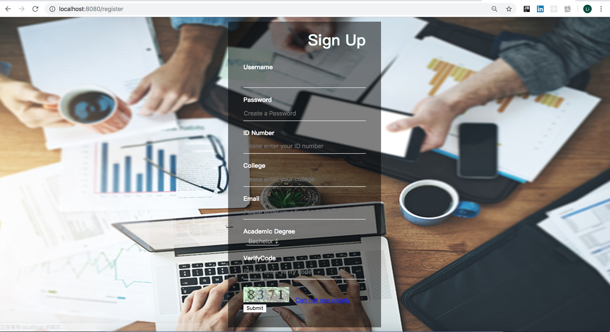

Key code in the register module.

2.2.1 View part (WEB-INF/jsp/register.jsp) :

<**script type="text/javascript"**>  
 **function** *changeImage*() {  
  
 ***document***.getElementById(**"img"**).**src** = **"${**pageContext.request.contextPath**}/imagecode?time="** + **new *Date***().getTime();  
 }  
 **function** *check*(){  
  
 **var** list = ***document***.getElementsByTagName(**"input"**);  
  
 **for**(**var** i=0;i<list.length;i++){  
 **if**(list[i].**value**==**""**){  
 *alert*(**"you should fill in the form"**);  
 **return false**;  
 }  
 }  
 **return true**;  
 }  
</**script**>

<**div class="SignUpBox"**>  
 <**h1**> Sign Up</**h1**>  
  
 <**form method="post" action="${**pageContext.request.contextPath**}/register.do" onsubmit="return** *check*()**"**>  
  
 <**font color="#ff0000"**>**${**email_msg**}**</**font**><**br** />  
 <**div**>  
 <**p**>Username</**p**>  
 <**div**>  
 <**input type="text" id="Username" placeholder="Create a Username" name="username"** />  
 </**div**>  
 </**div**>  
  
 <**div**>  
 <**p**>Password</**p**>  
 <**div**>  
 <**input type="password" id="password" placeholder="Create a Password" name="password"** />  
 </**div**>  
 </**div**>  
  
 <**div**>  
 <**p**>ID Number</**p**>  
 <**div**>  
 <**input type="text" id="id_number" placeholder="Please enter your ID number" name="id_number"** />  
 </**div**>  
 </**div**>  
  
 <**div**>  
 <**p**>College</**p**>  
 <**div**>  
 <**input type="text" id="college" placeholder="Please enter your college" name="college"** />  
 </**div**>  
 </**div**>  
  
 <**div**>  
 <**p**>Email</**p**>  
 <**div**>  
 <**input type="email" id="email" placeholder="Please enter your Email" name="email"** />  
 </**div**>  
 </**div**>  
  
 <**div**>  
 <**p**>Academic Degree</**p**>  
 <**div**>  
 <**select name="degree" id="degree"** >  
 <**option value="Bachelor"**>Bachelor</**option**>  
 <**option value="Master"**>Master</**option**>  
 <**option value="Phd"**>Phd</**option**>  
 </**select**>  
 </**div**>  
 </**div**>  
  
 <**font color="#ff0000"**>**${**errorMsg**}**</**font**><**br** />  
 <**div**>  
 <**p**>VerifyCode</**p**>  
 <**input type="text" id="checkCode" placeholder="Please enter verify code" name="checkCode"**/>  
 <**img src="${**pageContext.request.contextPath**}/imagecode" class="img" id="img"**/>**&nbsp;&nbsp;** <**a href="javascript:void(0);" onclick="***changeImage*()**"**>Can not see clearly</**a**>  
 </**div**>  
 <**div id="submit"**>  
 <**button type="submit" class="submit"**>Submit</**button**>  
 </**div**>  
</**form**>  
</**div**>

#### 2.2.2 Back-end part

a. (src/main/java/edu.monmouth.practicum/Controller/UserController)

@RequestMapping(**"register.do"**)  
**public** String Register(@Valid User user, HttpSession session, HttpServletRequest request) **throws** Exception {  
 String email = user.getEmail();  
 String RULE_EMAIL = **"^\\w+((-\\w+)|(\\.\\w+))*\\@[A-Za-z0-9]+((\\.|-)[A-Za-z0-9]+)*\\.[A-Za-z0-9]+$"**;  
 Pattern p = Pattern.*compile*(RULE_EMAIL);  
 Matcher m = p.matcher(email);  
 String checkCode = request.getParameter(**"checkCode"**);  
 Object cko = session.getAttribute(**"simpleCaptcha"**) ;  
 **if**(cko == **null**){  
 request.setAttribute(**"errorMsg"**, **"Too long time of this verified code, please rewrite verified code again！"**);  
 }  
 String captcha = cko.toString();  
 Date now = **new** Date();  
 Long codeTime = Long.*valueOf*(session.getAttribute(**"codeTime"**)+**""**);  
 **if**(StringUtils.*isEmpty*(checkCode) || captcha == **null** || !(checkCode.equalsIgnoreCase(captcha))) {  
 request.setAttribute(**"errorMsg"**, **"Verification code error!"**);  
 **return "register"**;  
 } **else if** ((now.getTime()-codeTime)/1000/60>5) {  
 *//验证码有效时长为5分钟* request.setAttribute(**"errorMsg"**, **"Verification code is invalid, please re-enter!"**);  
 **return "register"**;  
 }**else** {  
 **if**(m.matches()){  
 user.setVerified(0);  
 **userDao**.save(user);  
 session.setAttribute(**"user"**,user);  
 javaMail javaMail = **new** javaMail();  
 javaMail.sendmail(user.getEmail());  
 session.removeAttribute(**"simpleCaptcha"**);  
 session.setAttribute(**"user"**,user);  
 **return "login"**;  
 }  
 **else**{  
 session.setAttribute(**"email_msg"**,**"error email try it again"**);  
 **return "register"**;  
 }  
 }  
}  
@RequestMapping(**"register"**)  
**public** String RegisterView(){  
 **return "register"**;  
}

b. verify code (src/main/java/edu.monmouth.practicum/Controller/UserController)

@RequestMapping(**"imagecode"**)  
**public** String imagecode(HttpServletRequest request, HttpServletResponse response) **throws** Exception {  
 OutputStream os = response.getOutputStream();  
 Map<String,Object> map = ImageCode.*getImageCode*(60, 20, os);  
 String simpleCaptcha = **"simpleCaptcha"**;  
 request.getSession().setAttribute(simpleCaptcha, map.get(**"strEnsure"**).toString().toLowerCase());  
 request.getSession().setAttribute(**"codeTime"**,**new** Date().getTime());  
 **try** {  
 ImageIO.*write*((BufferedImage) map.get(**"image"**), **"JPEG"**, os);  
 } **catch** (IOException e) {  
 **return ""**;  
 }  
 **return null**;  
}

### 2.3 User center module

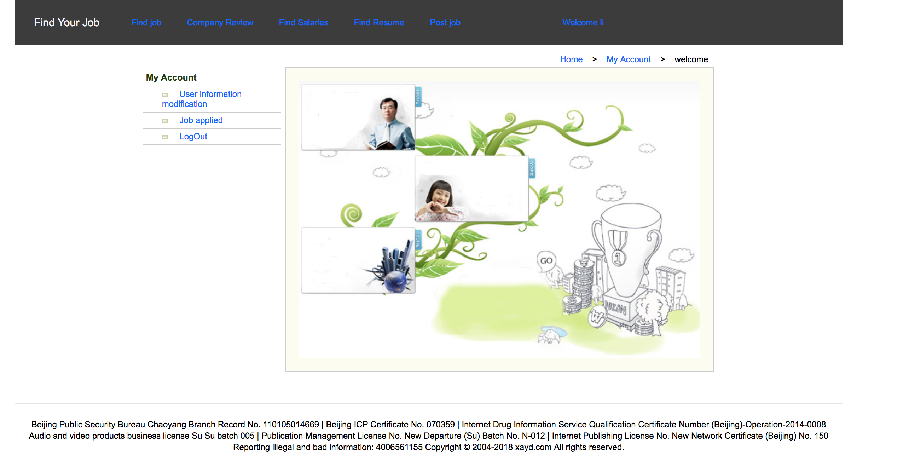

Key code in the register module.

2.3.1 View part (WEB-INF/jsp/myAccount.jsp) :

<**div id="divpagecontent"**>  
 <**table width="100%" border="0" cellspacing="0"**>  
 <**tr**>  
 <**td width="25%"**><**table width="100%" border="0" cellspacing="0"  
 style="margin-top**:30**px"**>  
 <**tr**>  
 <**td class="listtitle"**>My Account</**td**>  
 </**tr**>  
 <**tr**>  
 <**td class="listtd"**><**img src="images/miniicon.gif" width="9"  
 height="6"** />**&nbsp;&nbsp;&nbsp;&nbsp;** <**a  
 href="${**pageContext.request.contextPath**}/ModifyUserInfo"**>User information modification</**a**></**td**>  
 </**tr**>  
  
 <**tr**>  
 <**td class="listtd"**><**img src="images/miniicon.gif" width="9"  
 height="6"** />**&nbsp;&nbsp;&nbsp;&nbsp;** <**a href="${**pageContext.request.contextPath**}/show_jobapplied_list.do"**>Job applied</**a**>  
 </**td**>  
 </**tr**>  
 <**tr**>  
 <**td class="listtd"**><**img src="images/miniicon.gif" width="9"  
 height="6"** />**&nbsp;&nbsp;&nbsp;&nbsp;** <**a href="${**pageContext.request.contextPath**}/logout.do"**>LogOut</**a**>  
 </**td**>  
 </**tr**>  
 </**table**></**td**>  
 <**td**><**div style="text-align**:**right**; **margin**:5**px** 10**px** 5**px** 0**px"**>  
 <**a href="${**pageContext.request.contextPath**}/index"**>Home</**a**>**&nbsp;&nbsp;&nbsp;&nbsp;&gt;&nbsp;&nbsp;&nbsp;**<**a  
 href="${**pageContext.request.contextPath**}/myAccount.do"**>**&nbsp;**My Account</**a**>**&nbsp;&nbsp;&nbsp;&nbsp;&gt;&nbsp;&nbsp;&nbsp;&nbsp;**welcome  
 </**div**>  
 <**table cellspacing="0" class="infocontent"**>  
 <**tr**>  
 <**td style="padding**:20**px"**><**p**>  
 <**img src="images/myad.jpg" width="631" height="436"** />  
 </**p**>  
 </**td**>  
 </**tr**>  
 </**table**>  
 </**td**>  
 </**tr**>  
 </**table**>  
</**div**>

#### 2.3.2 Back-end part

a. (src/main/java/edu.monmouth.practicum/Controller/UserController)

@RequestMapping(**"myAccount"**)  
**public** String myAccountView(){  
 **return "myAccount"**;  
}

### 2.4 User information modification module

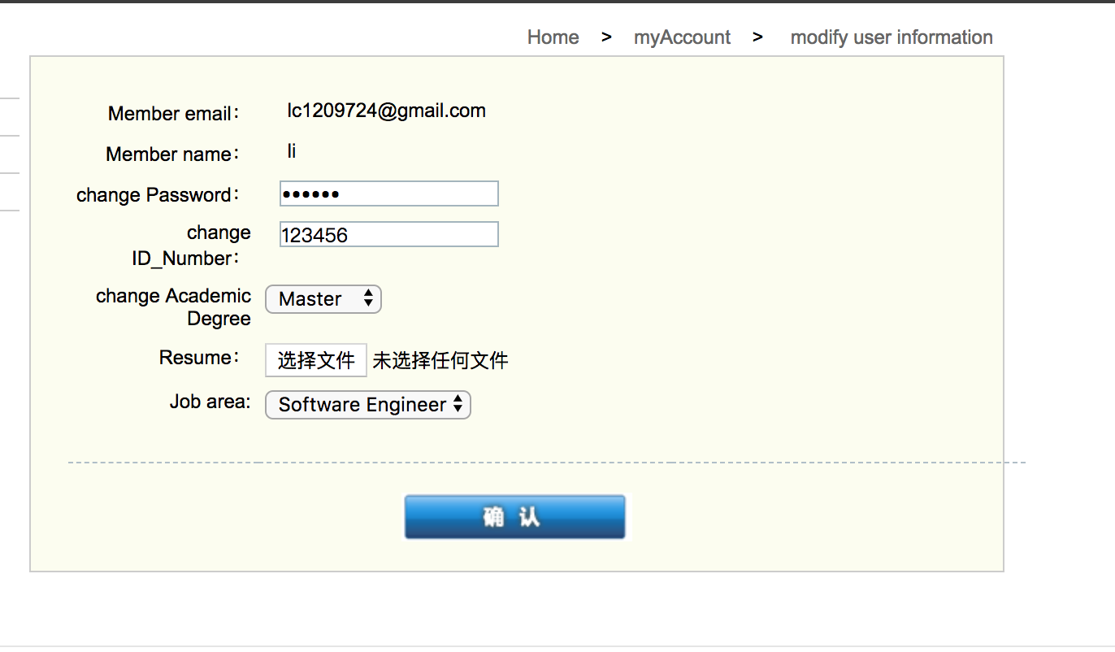

Key code in the register module.

2.4.1 View part (WEB-INF/jsp/modifyuserinfo.jsp) :

<**div id="divpagecontent"**>  
 <**table width="100%" border="0" cellspacing="0"**>  
 <**tr**>  
 <**td width="25%"**>  
 <**table width="100%" border="0" cellspacing="0"  
 style="margin-top**:30**px"**>  
 <**tr**>  
 <**td class="listtitle"**>My Account</**td**>  
 </**tr**>  
 <**tr**>  
 <**td class="listtd"**><**img src="images/miniicon.gif" width="9"  
 height="6"** />**&nbsp;&nbsp;&nbsp;&nbsp;** <**a  
 href="${**pageContext.request.contextPath**}/ModifyUserInfo"**>modfiy user information</**a**></**td**>  
 </**tr**>  
  
 <**tr**>  
 <**td class="listtd"**><**img src="images/miniicon.gif" width="9"  
 height="6"** />**&nbsp;&nbsp;&nbsp;&nbsp;** <**a href="${**pageContext.request.contextPath**}/show_jobapplied_list.do"**>Job applied</**a**>  
 </**td**>  
 </**tr**>  
  
 <**tr**>  
 <**td class="listtd"**><**img src="images/miniicon.gif" width="9"  
 height="6"** />**&nbsp;&nbsp;&nbsp;&nbsp;**<**a href="${**pageContext.request.contextPath**}/logout"**>Logout</**a**>  
 </**td**>  
 </**tr**>  
 </**table**></**td**>  
 <**td**>  
 <**div style="text-align**:**right**; **margin**:5**px** 10**px** 5**px** 0**px"**>  
 <**a href="index.jsp"**>Home</**a**>**&nbsp;&nbsp;&nbsp;&nbsp;&gt;&nbsp;&nbsp;&nbsp;**<**a  
 href="myAccount.jsp"**>**&nbsp;**myAccount</**a**>**&nbsp;&nbsp;&nbsp;&nbsp;&gt;&nbsp;&nbsp;&nbsp;&nbsp;** <**a href="${**pageContext.request.contextPath**}/findUserById?id=${**user.id**}"**>modify user information</**a**>  
 </**div**>  
  
  
  
 <**table cellspacing="0" class="infocontent"**>  
 <**tr**>  
 <**td**>  
 <**form action="${**pageContext.request.contextPath**}/ModifyUserInfo.do" method="post" enctype="multipart/form-data"**>  
 <**input type="hidden" name="id" value="${**u.id**}"**>  
 <**table width="100%" border="0" cellspacing="2" class="upline"**>  
 <**tr**>  
 <**td style="text-align**:**right**; **width**:20%**"**>Member email：</**td**>  
 <**td style="width**:40%; **padding-left**:20**px"**>**${**user.email**}**</**td**>  
 <**td**>**&nbsp;**</**td**>  
  
  
 </**tr**>  
 <**tr**>  
 <**td style="text-align**:**right"**>Member name：</**td**>  
 <**td style="padding-left**:20**px"**>**${**user.username**}**</**td**>  
 <**td**>**&nbsp;**</**td**>  
 </**tr**>  
 <**tr**>  
 <**td style="text-align**:**right"**>change Password：</**td**>  
 <**td**><**input type="password" name="password"  
 class="textinput" value="${**user.password**}"**/>  
 </**td**>  
 </**tr**>  
 <**tr**>  
 <**td style="text-align**:**right"**>change ID_Number：</**td**>  
 <**td**><**input type="text" name="id_number"  
 class="textinput" value="${**user.id_number**}"**/>  
 </**td**>  
 </**tr**>  
 <**tr**>  
 <**td style="text-align**:**right"**>change Academic Degree</**td**>  
 <**td**><**select name="degree" id="degree"** >  
 <**option value="Bachelor" ${**user.degree==**'Bachelor'**?**"selected='selected'"**:**""}**>Bachelor</**option**>  
 <**option value="Master" ${**user.degree==**'Master'**?**"selected='selected'"**:**""}**>Master</**option**>  
 <**option value="Phd" ${**user.degree==**'Phd'**?**"selected='selected'"**:**""}**>Phd</**option**>  
 </**select**>  
 </**td**>  
 </**tr**>  
 <**tr**>  
 <**td style="text-align**:**right"**>Resume：</**td**>  
 <**td**><**input type="file" name="file"** />  
 </**td**>  
 </**tr**>  
 <**tr**>  
 <**td style="text-align**:**right"**>Job area:</**td**>  
 <**td**><**select name="jobarea" id="jobarea"** >  
 <**option value="Anthropology" ${**user.jobarea==**'Anthropology'**?**"selected='selected'"**:**""}**>Anthropology</**option**>  
 <**option value="Accounting" ${**user.jobarea==**'Accounting'**?**"selected='selected'"**:**""}**>Accounting</**option**>  
 <**option value="Biology" ${**user.jobarea==**'Biology'**?**"selected='selected'"**:**""}**>Biology</**option**>  
 <**option value="Business" ${**user.jobarea==**'Business'**?**"selected='selected'"**:**""}**>Business</**option**>  
 <**option value="Nursing" ${**user.jobarea==**'Nursing'**?**"selected='selected'"**:**""}**>Nursing</**option**>  
 <**option value="Art" ${**user.jobarea==**'Art'**?**"selected='selected'"**:**""}**>Art</**option**>  
 <**option value="Finance" ${**user.jobarea==**'Finance'**?**"selected='selected'"**:**""}**>Finance</**option**>  
 <**option value="Management" ${**user.jobarea==**'Management'**?**"selected='selected'"**:**""}**>Management</**option**>  
 <**option value="Education" ${**user.jobarea==**'Education'**?**"selected='selected'"**:**""}**>Education</**option**>  
 <**option value="History" ${**user.jobarea==**'History'**?**"selected='selected'"**:**""}**>History</**option**>  
 <**option value="Music" ${**user.jobarea==**'Music'**?**"selected='selected'"**:**""}**>Music</**option**>  
 <**option value="Social Work" ${**user.jobarea==**'Social Work'**?**"selected='selected'"**:**""}**>Social Work</**option**>  
 <**option value="Psychology" ${**user.jobarea==**'Psychology'**?**"selected='selected'"**:**""}**>Psychology</**option**>  
 <**option value="Computer Science" ${**user.jobarea==**'Computer Science'**?**"selected='selected'"**:**""}**>Computer Science</**option**>  
 <**option value="Software Engineer" ${**user.jobarea==**'Software Engineer'**?**"selected='selected'"**:**""}**>Software Engineer</**option**>  
 </**select**>  
 </**td**>  
 </**tr**>  
 <**tr**>  
 <**td style="text-align**:**right"**>**&nbsp;**</**td**>  
 <**td**>**&nbsp;**</**td**>  
 <**td**>**&nbsp;**</**td**>  
 </**tr**>  
 </**table**>  
 <**p style="text-align**:**center"**>  
 <**input type="image" src="images/botton_gif_025.gif" border="0"**>  
  
 </**p**>  
 <**p style="text-align**:**center"**>**&nbsp;**</**p**>  
 </**form**></**td**>  
 </**tr**>  
 </**table**>  
 </**td**>  
 </**tr**>  
 </**table**>  
</**div**>

#### 2.4.2 Back-end part

a. (src/main/java/edu.monmouth.practicum/Controller/UserController)

@RequestMapping(**"ModifyUserInfo"**)  
**public** String ModifyUserInfoView(){  
 **return "modifyuserinfo"**;  
}  
@PostMapping(**"ModifyUserInfo.do"**)  
**public** String ModifyUserInfo(@RequestParam(**"password"**) String password,@RequestParam(**"id_number"**) String id_number,@RequestParam(**"degree"**) String degree,@RequestParam(**"jobarea"**) String jobarea,HttpSession session,@RequestParam(**"file"**) MultipartFile file, HttpServletRequest request){  
 User user1 = (User) session.getAttribute(**"user"**);  
 **if**(!id_number.equals(**""**)&&!password.equals(**""**)){  
 **userDao**.updateUser(password, Integer.*parseInt*(id_number),user1.getId());  
 }  
 **userDao**.updatejobarea_and_degree(jobarea,degree,user1.getId());  
 session.removeAttribute(**"user"**);  
 User user2 = **userDao**.findById(user1.getId());  
 session.setAttribute(**"user"**,user2);  
 **if**(!file.isEmpty()){  
 String saveFileName = file.getOriginalFilename();  
 **if**(saveFileName!=**null**){  
 String[] array = **new** String[2];  
 array = saveFileName.split(**"\\."**);  
 System.***out***.println(array[1]);  
 saveFileName = ((User) session.getAttribute(**"user"**)).getUsername()+**"_Resume."**+array[1];  
 }  
  
 File saveFile = **new** File(request.getServletContext().getRealPath(**"/Resume/"**)+saveFileName);  
 **if**(!saveFile.getParentFile().exists()){  
 saveFile.getParentFile().mkdir();  
 }  
 BufferedOutputStream bufferedOutputStream = **null**;  
 **try** {  
 bufferedOutputStream = **new** BufferedOutputStream(**new** FileOutputStream(saveFile));  
 bufferedOutputStream.close();  
  
 } **catch** (FileNotFoundException e) {  
 e.printStackTrace();  
 } **catch** (IOException e) {  
 e.printStackTrace();  
 }  
 **try** {  
 bufferedOutputStream.write(file.getBytes());  
 } **catch** (IOException e) {  
 e.printStackTrace();  
 }  
 **try** {  
 bufferedOutputStream.flush();  
 } **catch** (IOException e) {  
 e.printStackTrace();  
 }  
 **try** {  
 bufferedOutputStream.close();  
 } **catch** (IOException e) {  
 e.printStackTrace();  
 }  
 Resume resume = **new** Resume();  
 resume.setUsername(((User) session.getAttribute(**"user"**)).getUsername());  
 resume.setFilename(saveFileName);  
 **resumeDao**.save(resume);  
 **return "redirect:Home"**;  
  
 }**else** {  
 **return "redirect:Home"**;  
 }  
}

### 2.5 Logout module

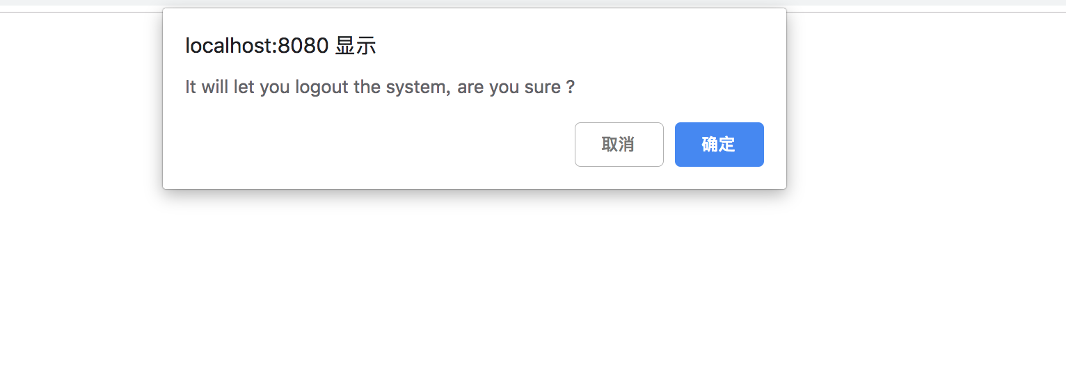

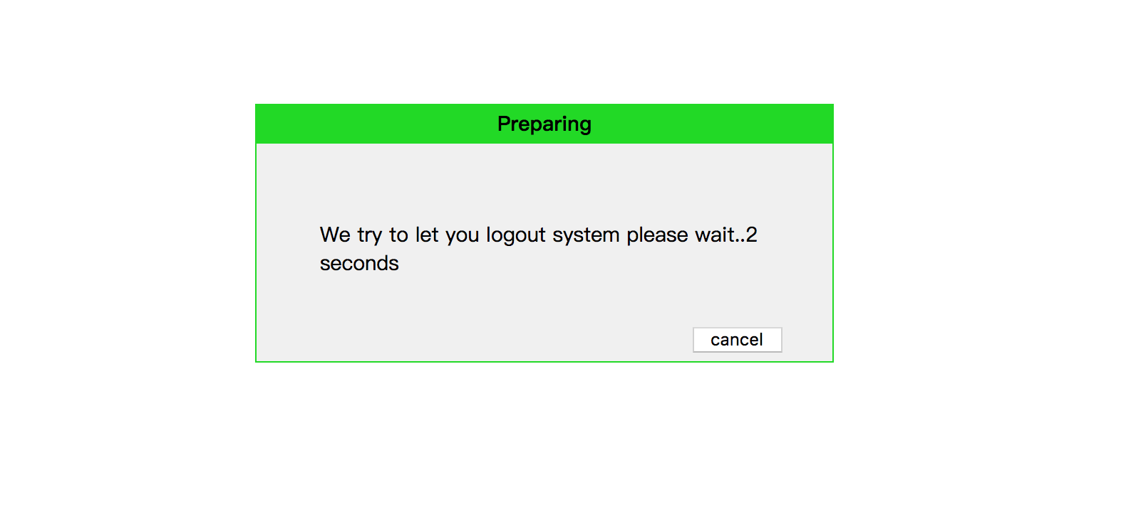

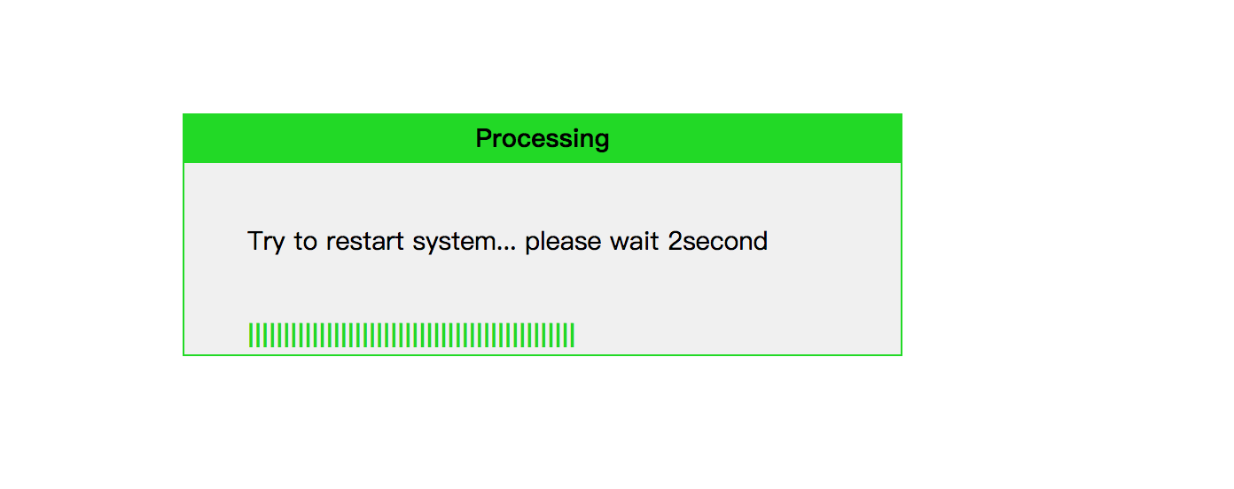

Key code in the Logout module.

2.5.1 View part (WEB-INF/jsp/logoutSuccess.jsp) :

<**div id="reboot_pre" style="width**: 450**px**; **height**: 200**px**; **margin-left**:**auto**; **margin-right**:**auto**; **margin-top**:200**px**; **visibility**:**hidden**; **background**: **#F0F0F0**; **border**:1**px solid #00DB00**; **z-index**:9999**"**>  
 <**div style="width**: 450**px**; **height**: 30**px**; **background**:**#00DB00**; **line-height**:30**px**;**text-align**: **center**;**"**><**b**>Preparing</**b**></**div**>  
 <**br** /><**br** />  
 <**div**><**p style="margin-left**:50**px"**>We try to let you logout system please wait..<**span id="reboot_pre_time"**>4</**span**> seconds</**p**></**div**>  
 <**br** />  
 <**div**><**button type="button" style="width**:70**px**; **height**:20**px**; **margin-left**:340**px" onclick="***reboot_cancel*()**"**>cancel</**button**></**div**>  
</**div**>

<**div id="reboot_ing" style="width**: 450**px**; **height**: 150**px**; **margin-left**:**auto**; **margin-right**:**auto**; **margin-top**:-150**px**; **visibility**: **hidden**; **background**: **#F0F0F0**; **border**:1**px solid #00DB00"**>  
 <**div style="width**: 450**px**; **height**: 30**px**; **background**:**#00DB00**; **line-height**:30**px**;**text-align**: **center**;**"**><**b**>Processing</**b**></**div**>  
 <**br** />  
 <**div**><**p style="margin-left**:40**px"**>Try to restart system... please wait <**span id="reboot_ing_time"**>17</**span**>second</**p**></**div**>  
 <**br** />  
 <**div id="progress_reboot" style="margin-left**:40**px**;**color**:**#00DB00**;**font-family**:**Arial**;**font-weight**:**bold**;**height**:18**px"**>|</**div**>  
 <**br** />  
</**div**>

<**script type="text/javascript"**>  
  
 **var *cancel_flag*** = 0;  
 **var *already*** = 0;  
  
 */* 网页一加载就执行的操作 */* ***window***.onload = *reboot*();  
  
 */* 重启按钮的单击操作 */* **function** *reboot*(){  
 **if**(*confirm*(**"It will let you logout the system, are you sure ?"**)){  
 ***document***.getElementById(**"reboot_pre_time"**).innerHTML = 4;  
 ***document***.getElementById(**"reboot_ing_time"**).innerHTML = 7;  
 ***document***.all.progress_reboot.**innerHTML** = **"|"**;  
 **download_flag** = 0;  
 ***cancel_flag*** = 0;  
 ***already*** = 0;  
 *setTimeout*(**"***showDiv***('reboot_pre')"**,500);  
 *delayPre_reboot*(**"reboot_pre_time"**);  
 }**else** {  
 ***window***.location.href=**"${**pageContext.request.contextPath**}/Home"**;  
 }  
 }  
 */* 重启准备弹窗计时 5秒 */* **function** *delayPre_reboot*(str) {  
 **if**(!***cancel_flag***){  
 **var** delay = ***document***.getElementById(str).innerHTML;  
 **if**(delay > 0) {  
 delay--;  
 ***document***.getElementById(str).innerHTML = delay;  
 *setTimeout*(**"***delayPre_reboot***('reboot_pre_time')"**, 1000);  
 } **else** {  
 *hideDiv*(**"reboot_pre"**);  
 *setTimeout*(**"***showDiv***('reboot_ing')"**,500);  
 *delayDo_reboot*(**"reboot_ing_time"**);  
 }  
 }  
 }  
 */* 重启进行中弹窗计时 15秒 */* **function** *delayDo_reboot*(str){  
 *display_reboot*(100);  
 **var** delay = ***document***.getElementById(str).innerHTML;  
 **if**(delay > 0) {  
 delay--;  
 ***document***.getElementById(str).innerHTML = delay;  
 *setTimeout*(**"***delayDo_reboot***('reboot_ing_time')"**, 1000);  
 } **else** {  
 *hideDiv*(**"reboot_ing"**);  
 *alert*(**"successful！"**);  
 ***window***.location.href=**"${**pageContext.request.contextPath**}/logout.do"**;  
 }  
 }**x** **function** *reboot_cancel*(){  
 ***cancel_flag*** = 1;  
 *hideDiv*(**"reboot_pre"**);  
  
 *alert*(**"you already cancel logout the system"**);  
 ***window***.location.href=**"${**pageContext.request.contextPath**}/Home"**;  
 }  
 **function** *showDiv* (str){  
 ***document***.getElementById(str).style.visibility = **"visible"**;  
 }**function** *hideDiv* (str){  
 ***document***.getElementById(str).style.visibility = **"hidden"**;  
 }  
  
 */* 重启进行中弹窗计时，缓冲条的移动*/* **function** *display_reboot*(max){  
 ***already***++;  
 **var** dispObj = ***document***.all.progress_reboot;  
 dispObj.style.width = 100.0\****already***/max+**"px"**;  
 ***document***.all.progress_reboot.**innerHTML** += **"|||||||||"**;  
 *// var timer = window.setTimeout("display("+max+")",1000);  
 // if (already >= max){  
 // window.clearTimeout(timer);  
 // }* }  
  
</**script**>

#### 2.5.2 Back-end part

a. (src/main/java/edu.monmouth.practicum/Controller/UserController)

@RequestMapping(**"logout"**)  
**public** String logoutView(){  
 **return "logoutSuccess"**;  
}  
@RequestMapping(**"logout.do"**)  
**public** String logout(HttpSession session){  
 session.invalidate();  
 **return "login"**;  
}

### 2.6 Findjob module

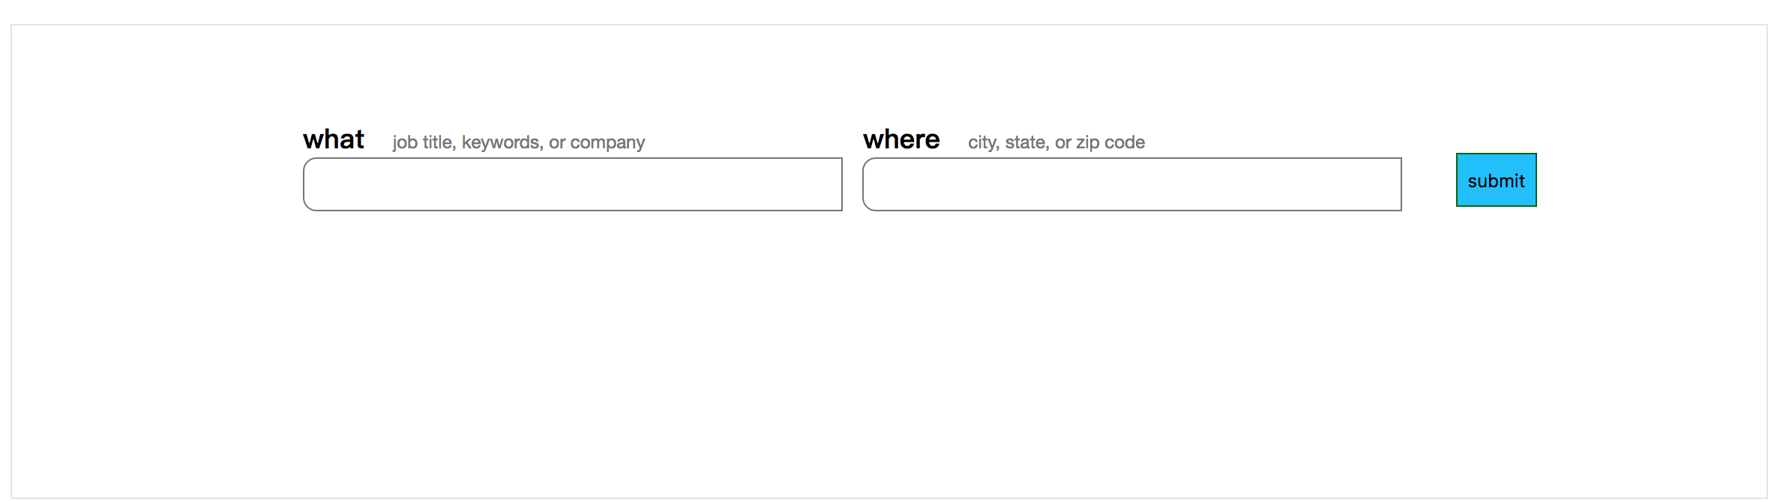

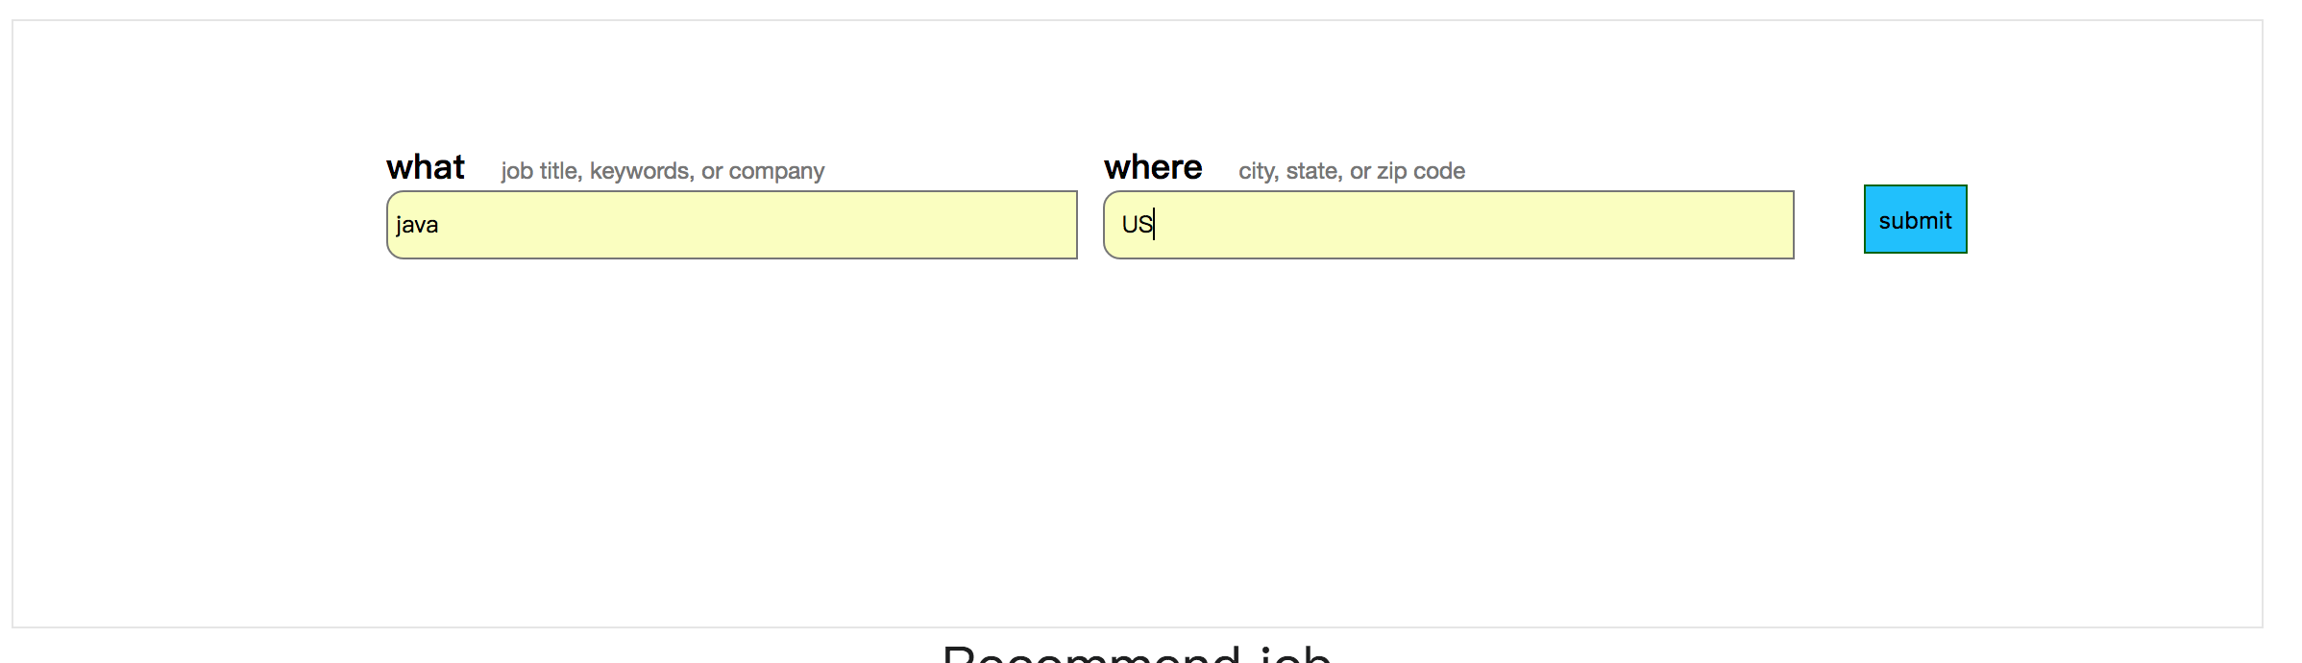

Key code in the Findjob module.

2.6.1 View part (WEB-INF/jsp/Home.jsp) :

<**div class="logo"**>Find Your Job</**div**>  
 <**ul**>  
 <**li**><**a href="#" class="nav-item"**>Find job</**a**></**li**>  
 <**li**><**a href="${**pageContext.request.contextPath**}/Company" class="nav-item"**>Company Review</**a**></**li**>  
 <**li**><**a href="#" class="nav-item"**>Find Salaries</**a**></**li**>  
 <**li**><**a href="#" class="nav-item" id="find_resume" onclick="***checkright*()**"**>Find Resume</**a**></**li**>  
 <**li**><**a href="#" class="nav-item" id="post" onclick="***checkpostright*()**"**>Post job</**a**></**li**>  
 <**li id="messages" style="padding-left**: 120**px"**><**a href="#" class="nav-item"**>Welcome **${**user.username**}**</**a**>  
 <**ul class="box" id="box"**>  
 <**li**><**a class="nav-item1" href="${**pageContext.request.contextPath**}/myAccount"**>User center</**a**></**li**>  
 <**li**><**a class="nav-item1" href="${**pageContext.request.contextPath**}/show_jobapplied_list.do"**>job applied</**a**></**li**>  
 <**li**><**a class="nav-item1" href="${**pageContext.request.contextPath**}/logout"**>Logout</**a**></**li**>  
 </**ul**>  
 </**li**>  
 </**ul**>  
  
 </**nav**>  
</**div**>

#### 2.6.2 Back-end part

a. (src/main/java/edu.monmouth.practicum/Controller/JobController)

@RequestMapping(**"/joblist"**)  
**public** String job_search(@RequestParam(**"jobname"**) String jobname, @RequestParam(**"location"**) String location, HttpSession session){  
 List<Job> jobs = **new** ArrayList<Job>();  
 jobs = **jobService**.Find_Job(**"%"**+jobname+**"%"**,**"%"**+location+**"%"**);  
 session.setAttribute(**"job_list"**,jobs);  
 **return "job_list"**;  
}

b. (src/main/java/edu.monmouth.practicum/Service/Jobservice)

**import** edu.monmouth.practicum.Dao.JobDao;  
**import** edu.monmouth.practicum.Domain.Job;  
**import** org.springframework.beans.factory.annotation.Autowired;  
**import** org.springframework.stereotype.Service;  
  
**import** javax.annotation.Resource;  
**import** javax.persistence.EntityManager;  
**import** javax.persistence.PersistenceContext;  
**import** javax.persistence.Query;  
**import** java.util.ArrayList;  
**import** java.util.List;  
  
@Service  
**public class** JobService {  
 @Autowired  
 @PersistenceContext  
 **private** EntityManager **entityManager**;  
 **public** List<Job> Find_Job(String jobname,String location){  
 String sql = **"select j.id,j.jobname,j.location,j.requirement,j.contact,j.jobarea,j.companyname from Job j where 1=1"**;  
 **if**(!**""**.equals(jobname.trim())&&!(jobname==**null**)){  
 sql+=**" and requirement like '"**+jobname+**"'"**;  
 }  
 **if**(!**""**.equals(location.trim())&&!(location==**null**)){  
 sql+=**" and location like '"**+location+**"'"**;  
 }  
 Query query = **entityManager**.createNativeQuery(sql,Job.**class**);  
 System.***out***.println(sql);  
 List<Job> jobs = **new** ArrayList<Job>();  
 jobs = query.getResultList();  
 **return** jobs;  
 }  
}

c. (src/main/java/edu.monmouth.practicum/Service/JobDao)

**import** edu.monmouth.practicum.Domain.Job;  
**import** org.springframework.data.jpa.repository.JpaRepository;  
  
**import** java.util.List;  
  
**public interface** JobDao **extends** JpaRepository<Job,Integer> {  
 List<Job> findByRequirementLike(String job);  
 List<Job> findByJobareaLike(String jobarea);  
 Job findById(**int** id);  
}